

Business Requirements Document (BRD)

Popcorn +

07 May 2017

Version 1.00

Damien Mc Geehan

# Document Revisions

|  |  |  |
| --- | --- | --- |
| Date | Version Number | Document Changes |
| 30/05/2017 | 0.1 | Initial Draft Of Documents |
|  |  |  |
|  |  |  |
|  |  |  |
|  |  |  |
|  |  |  |
|  |  |  |
|  |  |  |
|  |  |  |

# Approvals

|  |  |  |  |  |
| --- | --- | --- | --- | --- |
| **Role** | **Name** | **Title** | **Signature** | **Date** |
| Project Sponsor | Paul Herron | National Learning Network |  |  |
| Business Owner | Joe Bloggs | Galactica Cinemas |  |  |
| Project Manager | Damien Mc Geehan |  |  |  |
| System Architect | Darius Raisutis |  |  |  |
| Development Lead | Paulius Prichodko |  |  |  |
| Quality Lead | Shane Gallagher |  |  |  |
| Content Lead | Gabor Vajda |  |  |  |

# Introduction

## Project Summary

### Objectives

* Deliver a Movie Theatre Management System (MTMS) that synchronizes naming and linking of all movies in the systems across the cinema.
* Avoid duplication of Movie times and reduce time to production for existing projects.
* Support text searching on movie names or genre.
* Sync movie names and changes to Windows platform administration tools incorporated into this application.
* Tracks changes to movies including new movies, modified movie times, and movies to be archived.

### Background

Timely and accurate synchronization of movies will reduce levels of efforts across the organization by eliminating duplicate names of movies and overrun of cinema screen seating plan. The organization has uncovered seriously high levels of errors across booking, production of errors, and increased rework due to lack of knowledge about movie bookings already purchased .

#### Business Drivers

* Customers/Clerks are looking for faster updates to information on the Movie Database, and may consider competitors if needs are not met.
* Development group requires a scalable solution to track the movies being deployed to better manage resources.

## Project Scope

### In Scope Functionality

* Create name records for @widgets by category@ movies by Genre
  + Availability Supply
  + Administrator
  + Internal Database
* Ability to create/edit movies restricted by role(Administrator)
* Change Employee Records(Administrator)
* Add Employee(Clerk)
* Remove Employee(Clerk)
* Search by name, genre, length, time
* Update Database
* Synchronize movies to a Database
* Select Session/Screen/Time
* Display Movie
* Book Seats
* Print Ticket

### Out of Scope Functionality

## System Perspective

### Assumptions

* Inventory of existing movies by 08/06/2017.
* Testing data Production comprises of production data as of May 30.
* The product needs the following third party products.
* Microsoft SQL server to store the database.
* Asp.net to develop the product.

### Constraints

* Impending changes to database may impact data dictionary design.
* Timeline for project will impact execution of testing plan.

### Risks

* Previously approved development projects may limit availability of development and QA resources, necessitating outsourcing for additional time to meet the anticipated deadline.

### Issues

See Issue Report

# Business Process Overview

## Current Business Process (As-Is)

At this point the Theatre Management system is manual and time consuming for the company. The Company has to meet the increasing demand for availability of movies and customer for ease of use. At any point during or after deployment of the application (internal) to support business activities, development/support teams may create and deploy more features.

1. Administrators for the Current system to create or edit movie details.
2. Administrators must check movies and employee into a manual filing system.

Use Care Reference # : US-01

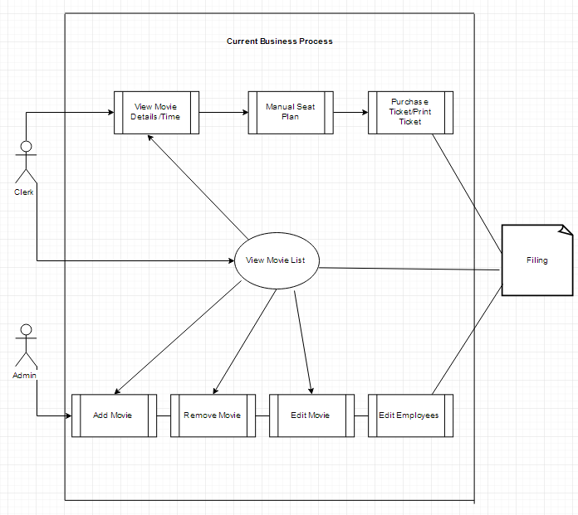

## Proposed Business Process (To-Be)

1. Administrators can edit employees
2. If a new movie is found, admin creates a new movie record.
3. MTMS validates that all fields have been completed.
4. MTMS confirms that no similar movies exist on database
5. Admin confirms record to be created.
6. Clerk searches Movie List to locate existing Movie database.
7. MTMS Clerks displays Movie List/times/available seats
8. Clerk selects to open and modify Movie Seat Plan
9. MTMS validates all fields completed correctly
10. Clerk confirms changes to Movie Screen Seat Plan.
11. MTMS confirms changes and updates Seat Plan table.

Use Care Reference # : US-02

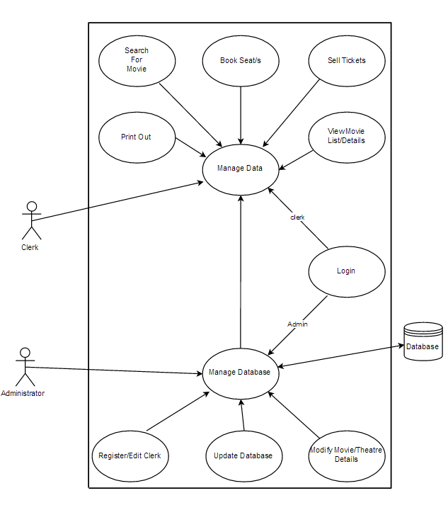

# Business Requirements

The requirements in this document are prioritized as follows:

|  |  |  |
| --- | --- | --- |
| **Value** | **Rating** | **Description** |
| 1 | Critical | Communication with the database. |
| 2 | High | Logical Specification of the application. |
| 3 | Medium | Correct Error Messages |
| 4 | Low | Add or Edit employee functionality |
| 5 | Future | Online Customer Booking Website |

## Functional Requirements

| **Req#** | **Priority** | **Description** | **Rationale** | **Use Case Reference** | **Impacted Stakeholders** |
| --- | --- | --- | --- | --- | --- |
| General / Base Functionality | | | | | |
| FR-4-3-1 | 1 | Common Function:  Login | Both Admin and Clerks must be logged in before they modify any information | US-02 | Development teams  Administrator/s  Clerk/s |
| FR-4-3-2 | 1 | Common Function:  Search for movie | When administrator or clerk wants to search movie by genre or name | US-02 | Development teams  Administrator/s  Clerk/s |
| FR -4-1-1 | 1 | Administrator:  Add Movie: | This action is done to add a new movie to Movie theatre database. | US-02 | Development teams  Administrator/s  Clerk/s |
| FR-4-1-2 | 1 | Administrator:  Edit Movie: | This event is to modify movies information. | US-02 | Development teams  Administrator/s  Clerk/s |
| FR-4-1-3 | 1 | Administrator:  Delete Movie: | This event is to delete an existing movie. | US-02 | Development teams  Administrator/s  Clerk/s |
| FR-4-1-4 | 1 | Administrator:  Manage Movie Screen: | This action is to view, edit or add to the seat plan of the screen. | US-02 | Development teams  Administrator/s  Clerk/s |
| FR-4-1-5 | 1 | Administrator:  Sell tickets: | This action is to sell tickets to customers. | US-02 | Development teams  Administrator/s  Clerk/s |
| FR-4-1-6 | 1 | Administrator:  View currently showing films: | View movie showing times and screens. | US-02 | Development teams  Administrator/s  Clerk/s |
| FR-4-1-7 | 1 | Administrator:  Access: | Administrator has all rights of access to the database | US-02 | Development teams  Administrator/s  Clerk/s |
| FR-4-2-1 | 2 | Clerk:  Manage Movie Screen: | This action is to view, edit or add to the seat plan of the screen. | US-02 | Development teams  Administrator/s  Clerk/s |
| FR-4-2-2 | 2 | Clerk:  Sell tickets: | This action is to sell tickets to customers. | US-02 | Development teams  Administrator/s  Clerk/s |
| FR-4-2-3 | 2 | Clerk:  View currently showing films: | View movie showing times and | US-02 | Development teams  Administrator/s  Clerk/s |
| Security Requirements | | | | | |
| FR-6-4 | 1 | System will use a secured database. | Normal users/clerks can just read information. Add or edit reservations to the seat booking plan. System will have 2 different types of users. Administrators will have unrestricted access and clerks/users have access constraints. | US-02 | Development teams  Administrator/s  Clerk/s |
| Error Reporting Requirements | | | | | |
| FR-6-1 | 2 | Error Handling | Movie theatre management system shall handle expected and non-expected errors in ways that prevent loss in information and long downtime period. | US-02 | Development teams  Administrator/s  Clerk/s |
| Usability Requirements | | | | | |
| FR-U-001 | 1 | User interface | User interface for the MTMS database shall be responsive, allowing for proper display on desktop | US-02 | Development teams  Administrator/s  Clerk/s |
| Database Requirements | | | | | |
| FR-2-5-3 | 1 | Sql Server | The database is available during work times 9am – 11pm – 14 hours a day | US-02 | Development teams  Administrator/s  Clerk/s |

## Non-Functional Requirements

|  |  |
| --- | --- |
| **ID** | **Requirement** |
| NFR-6-1 | MTMS shall handle expected and non-expected errors in ways that prevent loss in information and long downtime period. |
| NFR-6-2 | The system shall accommodate high number of movies and users without any fault. |
| NFR-6-3 | System user shall not cause any harm to human users. |
| NFR-6-4-1 | System will use a secured database |
| NFR-6-4-2 | Normal users/clerks can just read information. Add or edit reservations to the seat booking plan. |
| NFR-6-4-3 | System will have 2 different types of users. Administrators will have unrestricted access and clerks/users have access constraints. |

# Appendices

## List of Acronyms

MTMS – Movie Theatre Management System.

## Related Documents

1. Popcorn+ :Software Requirements Specification